PROJECT ON BRITISH AIRWAYS REVIEWS

Project Overview:
This study presents an interactive Power BI dashboard developed to analyze British Airways customer review data across multiple dimensions, including country, aircraft type, traveler category, and time period. The dataset comprises structured passenger feedback with overall ratings and service-specific evaluations such as cabin staff service, seat comfort, food and beverages, ground service, and value for money. The dashboard enables comparative analysis of average ratings by country and aircraft, identifies highest- and lowest-rated locations, and examines monthly trends in customer satisfaction. Dynamic filters allow users to explore specific segments of interest, supporting granular analysis of passenger experiences. The findings provide actionable insights into service performance variability and highlight areas for improvement, demonstrating the effectiveness of data visualization techniques in supporting customer experience analysis within the airline industry.

Objectives:
- Analyse overall customer satisfaction trends using passenger review ratings across multiple time periods.
- Compare average ratings across countries to identify highest- and lowest-performing locations.
- Evaluate service quality dimensions, including cabin staff service, seat comfort, food and beverages, ground service, and value for money.
- Assess customer satisfaction by aircraft type to understand the impact of operational assets on passenger experience.
- Enable interactive, filter-driven analysis by traveller type, country, and year to support targeted, data-driven decision-making.

Analyses:
POWER BI has been used with additional DAX queries for new measures to create the dashboards.
DASHBOARDS:
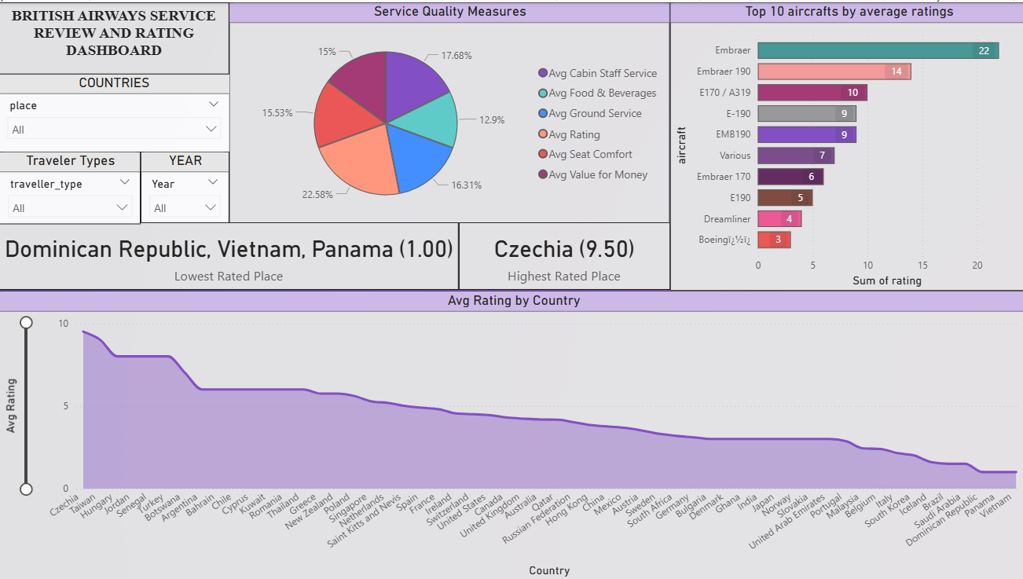
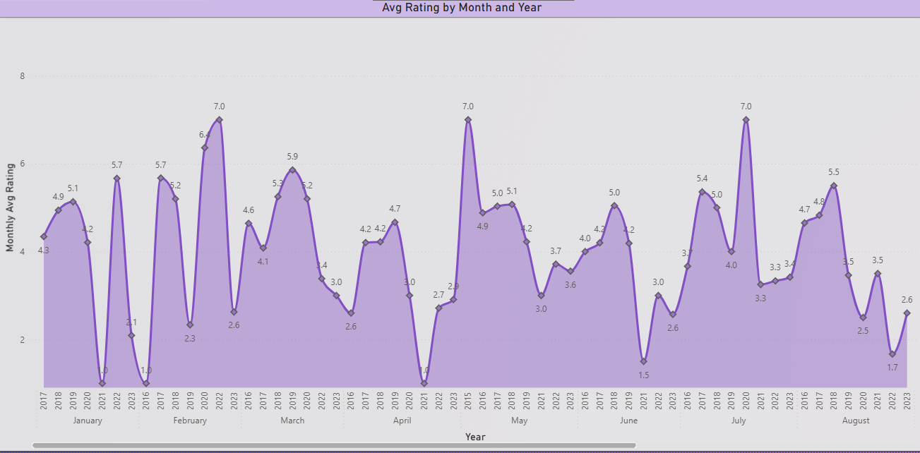

CHARTWISE ANALYSES:
- Service Quality Measures (Pie Chart): This chart presents the proportional contribution of different service quality dimensions to the overall customer experience. Among the evaluated metrics, overall rating and value for money contribute the largest shares, indicating that passengers place significant emphasis on perceived value and their holistic travel experience. Cabin staff service and ground service show moderately strong contributions, reflecting consistent service delivery in these areas. Food & beverages and seat comfort contribute relatively smaller portions, suggesting potential opportunities for service enhancement in these categories to improve overall customer satisfaction.
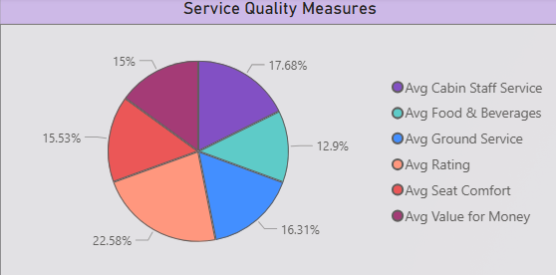

- Top 10 Aircraft by Average Ratings (Bar Chart): This chart compares aircraft types based on aggregated customer ratings. Certain aircraft models, such as Embraer variants, demonstrate consistently higher average ratings, indicating better passenger comfort or service alignment. Conversely, lower-rated aircraft types suggest areas of cabin layout, onboard amenities, or service delivery may require improvement. The visualization helps airline management prioritize fleet-level enhancements by identifying aircraft types that have a direct impact on passenger satisfaction.

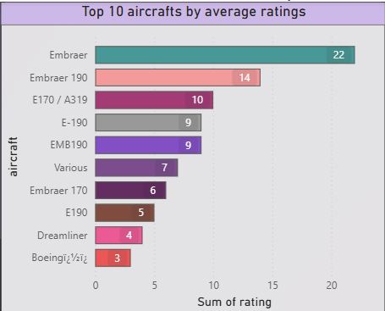

- Highest and Lowest Rated Places (KPI Cards): The KPI cards highlight geographical extremes in customer satisfaction. Czechia emerges as the highest-rated location, reflecting strong service consistency and positive passenger experiences. In contrast, Dominican Republic, Vietnam, and Panama appear as the lowest-rated locations, that signals potential regional service gaps or operational challenges. These insights enable targeted regional interventions rather than broad, uniform service changes.

- Average Rating by Country (Area Chart): This chart ranks countries based on average customer ratings, providing a comparative view of service performance across regions. A clear downward trend from highest- to lowest-rated countries indicates substantial variability in customer experience across markets. Higher-rated countries demonstrate stronger service alignment, while lower-rated regions may require focused operational or service quality improvements. This visualization supports strategic benchmarking across geographies.
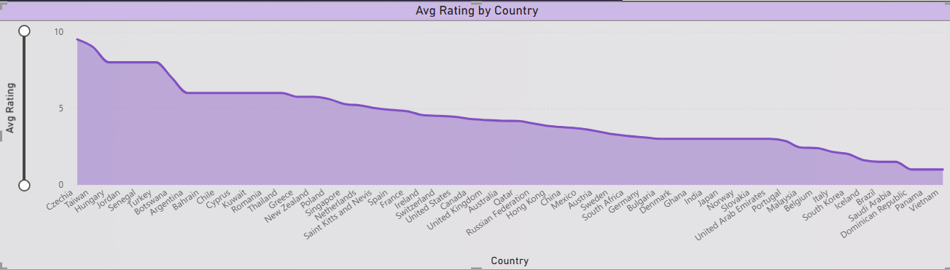

- Average Rating by Month and Year (Line Chart): This time-series chart tracks monthly variations in average customer ratings across multiple years. The visualization reveals noticeable fluctuations, suggesting seasonal effects, demand surges, or operational pressures during certain months. Peaks indicate periods of strong service performance, while dips may correspond to high-traffic seasons or resource constraints. This insight allows management to proactively plan staffing, service levels, and operational capacity during high-risk periods.
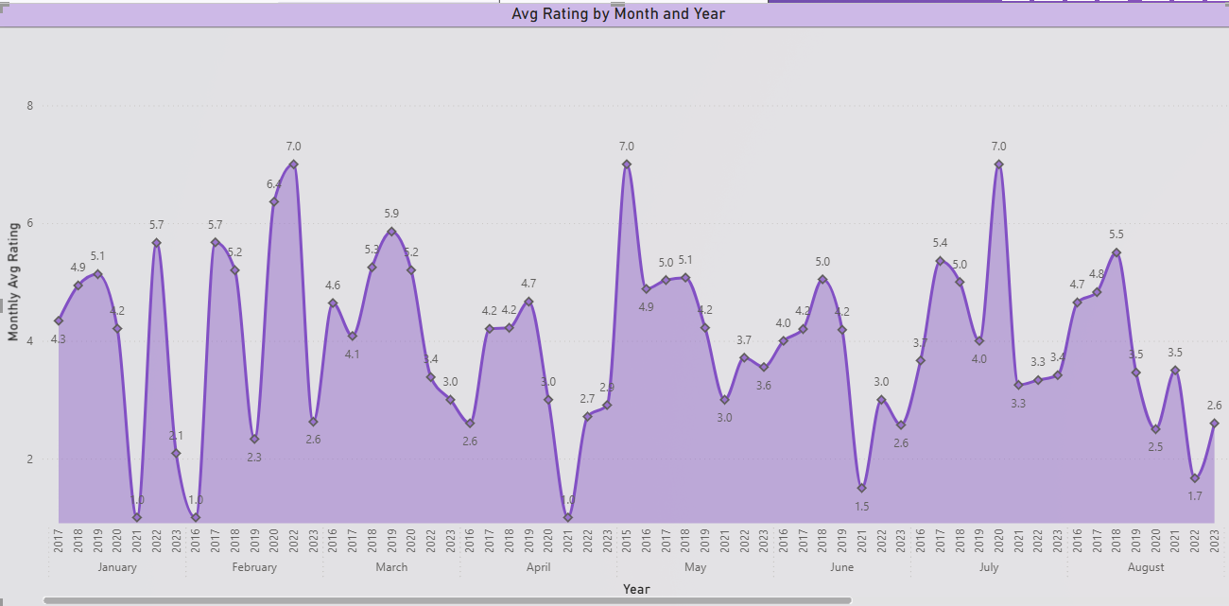

- Interactive Filters (Slicers): The country, traveller type, and year slicers enhance analytical flexibility by allowing users to dynamically adjust the scope of analysis. These filters support granular exploration of specific passenger segments, routes, or time frames, enabling stakeholders to isolate problem areas and assess the impact of targeted improvements over time.
